Design Plan: | Document Name: Process Design Document | SWD/Form No.7
Effective Date : 08/09/2008 | Version : 1 | Page No. 43

1. Form Buffet Manager Algorithms

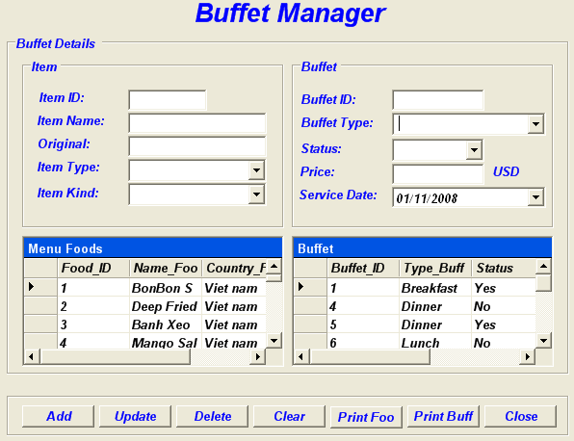

1.1 Add Buffet Algorithmt
Start
Show Buffet Manager Form
Validate
Informationn
Input information
Error!
No
Check
In DataBase
Exception!
Incorrect
Yes
Insert Successful!

Correct
Insert
Into DataBase
The End
1.2 Delete Buffet & Foods Algorithmt.
Start
Show Buffet Manager Form
Validate
ID Input
Input ID would delete
Error!
No
Check
In DataBase
Exception!
Incorrect
Yes
Deleted Successful!

Correct
Delete
From DataBase
The End

1.3 Update Buffet & Food Algorithmt.

Start
Show Buffet Manager Form
Press Update Button
Check
In DataBase
Exception!
Incorrect
Update DataGrid
Successful!
Correct
Loading New
DataBase
The End

1.4 Buffet Manager Print Algorithmt.

Start
Show Buffet Manager Form
Press Print Button
Check
Printer
Exception!
Incorrect
Print
Successful!
Correct
Print
Information
The End

2. Form Booking Buffet.

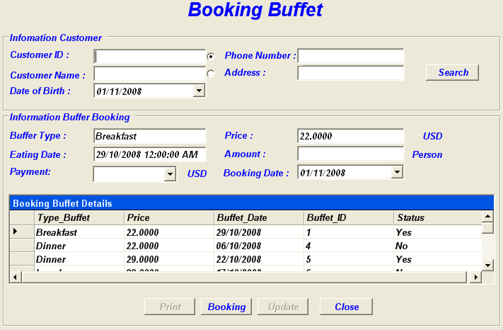

2.1 Booking Buffet Algorithmt.
Start
Show Booking
Buffet Form
Validate
Informationn
Input Booking
Information
Error!
No
Check Information Into
DataBase
Exception!
Incorrect
Yes
Insert
Successful!
Correct
Save Information
Into Database
The End

2.2 Update Booking Buffet Algorithmt.
Start
Show Booking
Buffet Form
Press Update Button
Check
In DataBase
Exception!
Incorrect
Update DataGrid
Successful!
Correct
Loading New
DataBase
The End

2.3 Print Booking Buffet Algorithmt

Start
Show Booking Buffet Form
Press Print Button
Check
Printer
Exception!
Incorrect
Print
Successful!
Correct
Print
Information
The End

2.4 Search Booking Buffet Algorithmt.

Start
Show Booking
Buffet Form
Validate
Informationn
Input Search
Information
Error!
No
Search Information Into
DataBase
Exception!
Incorrect
Yes
Search
Successful!
Correct
Loading
Information
The End

3. Form Buffet Order.

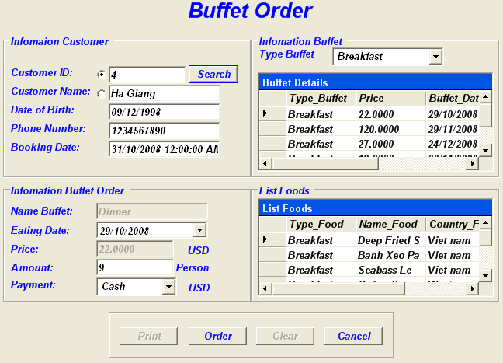

3.1 Search Buffet Order Algorithmt.
Start
Show Buffet Order Form
Validate
Informationn
Input Search
Information
Error!
No
Search Information Into
DataBase
Exception!
Incorrect
Yes
Search
Successful!
Correct
Loading
Information
The End

3.2 Order Buffet Algorithmt.
Start
Show Buffet
Order Form
Validate
Informationn
Input information
Error!
No
Check
In DataBase
Exception!
Incorrect
Yes
Insert
Successful!
Correct
Insert
Into DataBase
The End

3.3 Print Buffet Order Algorithmt.
Start
Show Buffet
Order Form
Press Print Button
Check
Printer
Exception!
Incorrect
Print
Successful!
Correct
Print
Information
The End

4. Form Bill Buffet.

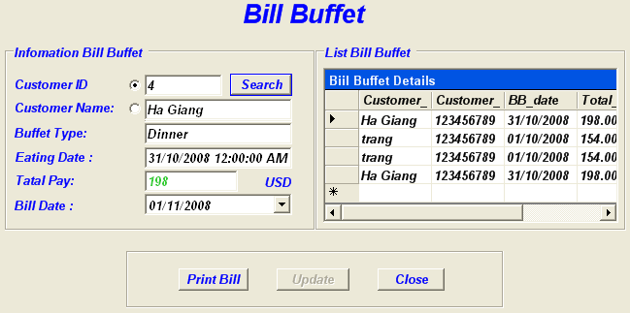

4.1 Save Bill Buffet Algorithmt.
Start
Show Bill
Buffet Form
Validate
Informationn
Input information
Error!
No
Check
In DataBase
Exception!
Incorrect
Yes
Save
Successful!
Correct
Save Data
Into DataBase
The End

4.2 Update DataGrid Bill Buffet.

Start
Show Bill
Buffet Form
Press Update Button
Check
In DataBase
Exception!
Incorrect
Update DataGrid
Successful!
Correct
Loading New
DataBase
The End

4.3 Print Bill Buffet Algorithmt.

Start
Show Bill
Buffet Form
Press Print Button
Check
Printer
Exception!
Incorrect
Print
Successful!
Correct
Print
Information
The End

4.4 Search Bill Buffet Algorithmt.

Start
Show Bill
Buffet Form
Validate
Informationn
Input Search
Information
Error!
No
Search Information Into
DataBase
Exception!
Incorrect
Yes
Search
Successful!
Correct
Loading
Information
The End

5. Form Bussiness Report.

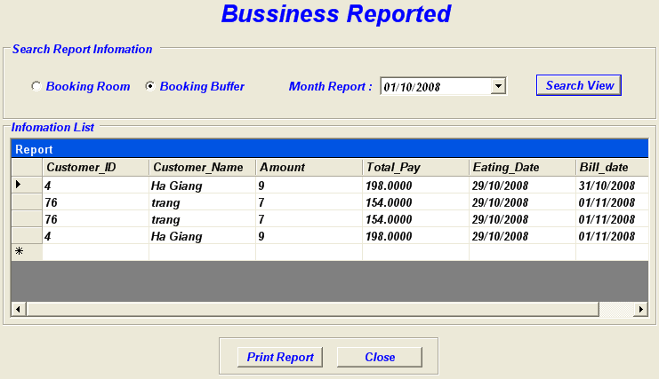

5.1 Print Business Report algorithmt.

Start
Show Business
Report Form
Press Print Button
Check
In Database
Exception!
Incorrect
Report
Successful!
Correct
Loading
Report Information
The End

5.2 Search Business Report algorithmt.
Start
Show Business
Report Form
Validate
Information
Input Search
Information
Error!
No
Search Information Into
DataBase
Exception!
Incorrect
Yes
Search
Successful!
Correct
Loading
Information
The End

6. From check out.

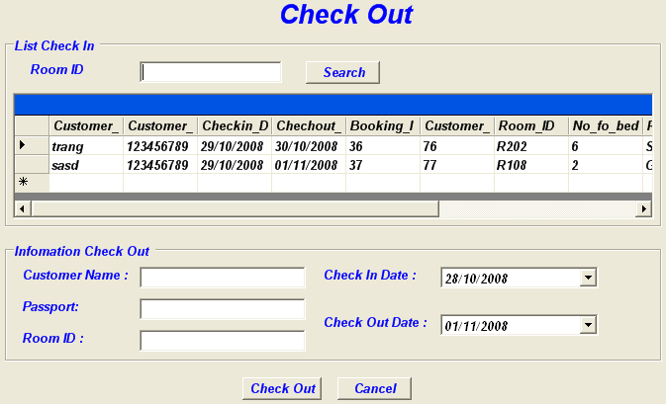
6.1 CheckOut Algorithmt
Start
Display check out form
Choice customer
Check out
End

7. Login form.

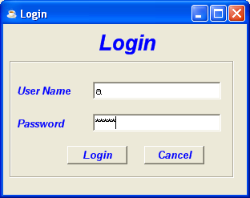
7.1 Login Algorithmt.
False
True
Display Login Form
Input Username and Password
Successful message
End
Start
Check Useraname and Password
Error message

End

7. Form User manager.

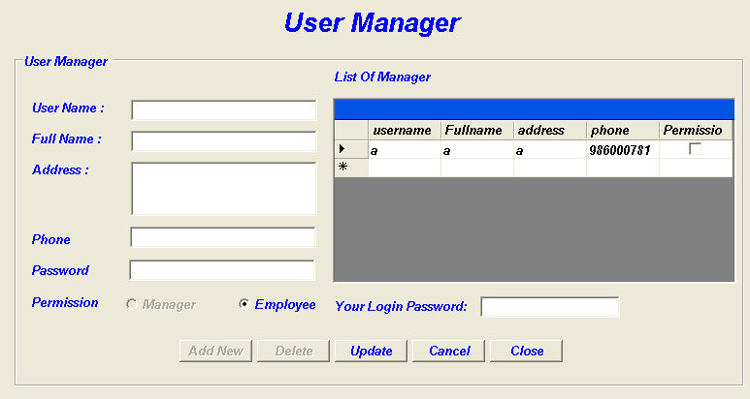

7.1 Add New Algorithmt.
Begin
Display User Manager Form

Check User name
Error Message

Input information

End
True
False
Check Full name
Check address
Check phone
Check password
True
True
True
False
False
False
False
Add Information

7.2 Delete Algorithmt.

End
Start
Display User Manager From

Select User to delete
Delete

7.3 Update Algorithm.
End
Error Message

Begin
Check user name

Display User Manager From

True
False
Select User to update

Edit information of User

Check full name

Check address

Check phone

Check password

True
True
True
False
False
False
False
Update Information

8. Form Customer.

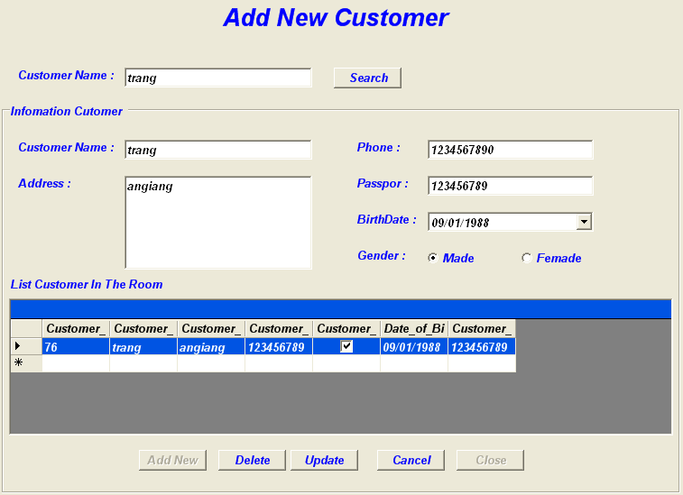

8.1 Add New Algorithm.
End
True
Begin
Display Customer Form

Check customer name
Error Message

False
Input information

Check address
Check phone
Check passport
True
True
True
False
False
False
Add Information

8.2 Update Algorithm.
End
Error Message

Begin
Check customer name

Display Customer From

True
False
Select Customer to update

Edit information of Customer

Check address

Check phone

Check passport

False
False
False
True
True
Update Information

8.3 Delete Algorithm.

End
Begin
Display Customer From

Select Customer to delete

Delete

9. Form Search Room.

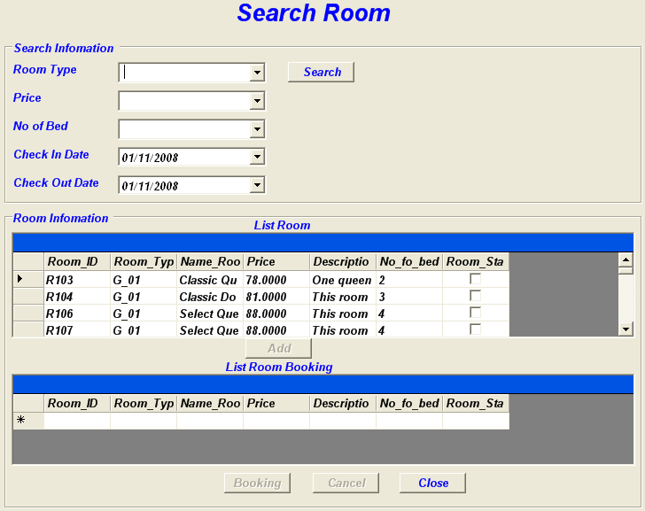

9.1 SEARCH ROOM Algoritmt.
Begin
Display form Search Room on screen
Select information need to Search
Access to database
Test database
Display All Rooms available
End
Message no found
Y
N
Select one Rooms available
Click button Add
Select Room in datagrid process add
in the process of ...
Kiến nghị đang được xem xét
A petition under consideration
Danh sách bệnh nhân đang (được ) điều trị
List of patients under treatment
Xe đang sửa
A car in the process of being repaired/under repair
" Đang hành lễ "
"Service in progress"
Đừng nói khi người ta đang diễn !
Don't speak while the performance is in progress !
Báo cáo về các chương trình đang thực hiện
To make a report on the programs in progress/under way
Cô ấy ngủ gật khi đang làm việc
She fell asleep while on duty
Tôi đang tập thể dục
I am taking exercise
Lúc ấy tôi đang tập thể dục
At that time, I was taking exercise

Click button Booking

Message complete

10. Form Booking Room.

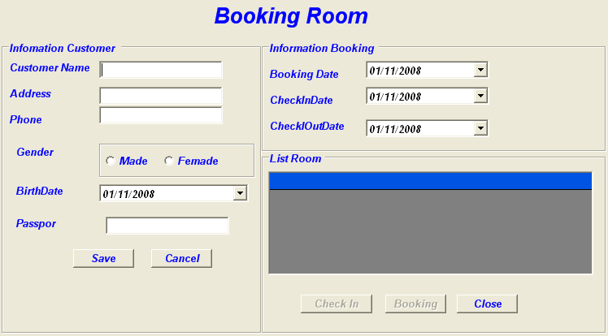

10.1 BOOKING ROOM Algorithmts.
Begin
Display form Booking Room on screen
Input information Customer in form
Test Valid
End
Message error
Save on database
Y
N
Choice Room in Datagrid needs Book

Click button Booking

Message complete

Successful

Message error
N
Y

11. Form Check in Room.

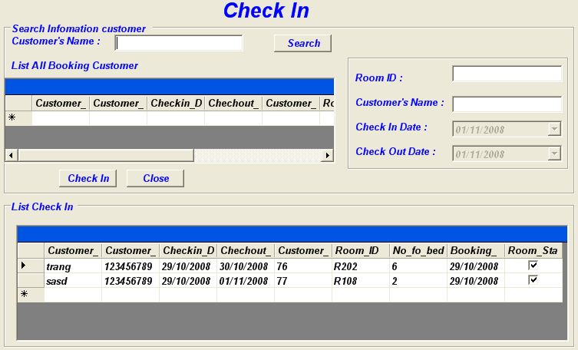

11.1 CHECK IN Algorithmts.

Begin
Display form Booking Room on screen

Click button Check In
End
Input information in form needs Check In

Message successful
Test Valid
Message error
Save on database
N
Y
Choice Room in Datagrid Check In

Successful

Message error
N
Y

12. From Change Room:

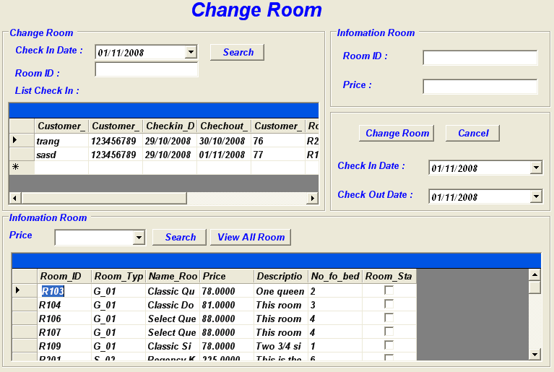

12.1 Change Room Algorithmt.

Begin
Display form Change Room In on screen
End
Select Room needs Change Room
Search information Room available

Select Room new needs Check In

Click button Change Room
Message no found

Test Room

N
Y
Access to database
Message successful

13.Form Bill Room

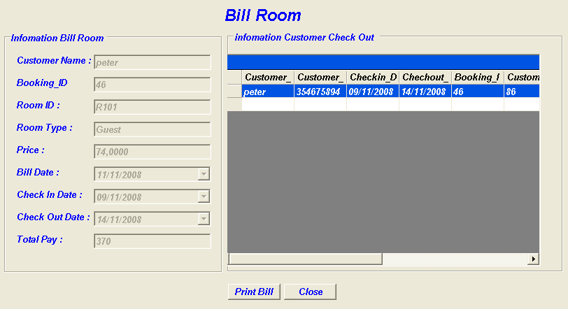

13.1 Bill Room Algorithmt.

Start
Load customer information
Save information
Print Bill
End

 | Prepared By (Student) | Approved By (Teacher)
Date: 14/10/2008 | Group IV | Tran Thi Hong An

Design Plan: | Document Name: Algorithms | SWD/Form No.7
Effective Date : 08/11/2008 | Version : 1 | Page No.

Flow of the Application.
DeltaHotel
Application
Display
Main Window
Display Food & Buffet Manager Window
Display Login Successful
Display Login Window
Display Booking Buffet Window
Display Buffet Order Window
Display Bill Buffet Window
Display Search Room Window
Display Booking Room Window
Display Check In Room Window
Display Change Room Window
Display Check Out Room Window

Display Bill Room Window

Display User Manager Window
Display Add new Customer Window
Display Report Business Window
Select Menu
Window
Display Login False
Display Login Window
Validate Login Information

No
Yes

Project Plan | Prepared By (Student) | Approved By (Teacher)
Date: 01/11/2008 | Khai | Tran Thi Hong An

